My life story

(Past present and future)

Insert your **photo** here.



My name is:

I like to be called:

Widgit Symbols and Pictures. Copyright Widgit Software 204-2014 [www.widgit.com](http://www.widgit.com)



Interesting information about me.

|  |
| --- |
|  |

My family

|  |  |  |
| --- | --- | --- |
| **photo** |  | Partners name |

|  |  |  |
| --- | --- | --- |
| **photo** |  | Children’s name |

|  |  |  |
| --- | --- | --- |
| **photo** |  | Grandchildren’s name |

|  |  |  |
| --- | --- | --- |
| **photo** |  | Mother’s name |

|  |  |  |
| --- | --- | --- |
| **photo** |  | Father’s name |

|  |  |  |
| --- | --- | --- |
| **photo** |  | Brother’s and Sister’s name |

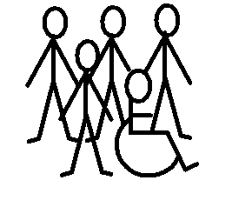

People who are important to me.

|  |  |  |  |
| --- | --- | --- | --- |
| Their name | Where they live. | When I see them | What we do. |
| Their name | Where they live. | When I see them | What we do. |
| Their name | Where they live. | When I see them | What we do. |

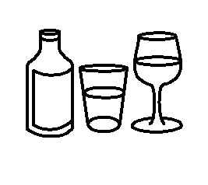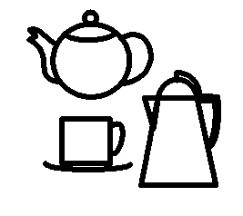

What I like to drink

|  |  |
| --- | --- |
| When I get up |  |
| With breakfast |  |
| With dinner |  |
| Hot drinks I like |  |
| Cold drinks I like |  |
| When I go out |  |

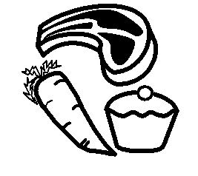

Food I like.

|  |  |
| --- | --- |
| For breakfast |  |
| For snacks |  |
| For cold meals |  |
| For hot meals |  |
| For celebrations |  |
| When I go out |  |



Food I like.

|  |
| --- |
|  |

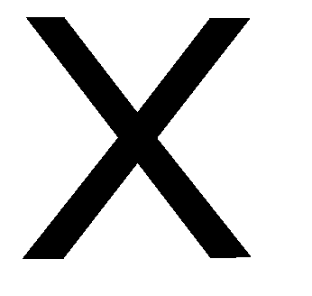

Food and drink I don’t like.

|  |
| --- |
|  |

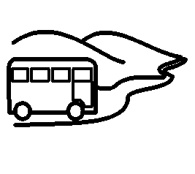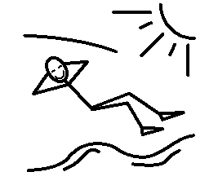

Day trips and holidays.

|  |  |
| --- | --- |
| Day trips |  |
| Weekends away |  |
| Visiting people |  |
| Holidays |  |
| Other |  |



Day trips and holidays.

|  |
| --- |
|  |

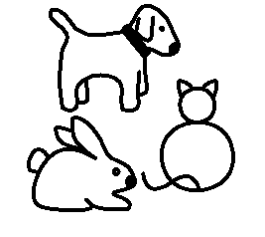

My pets.

|  |  |
| --- | --- |
| Pets I had as a child and adult | What I like about pets |
|  | |

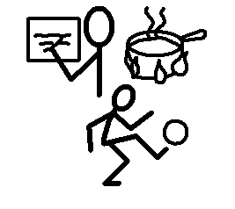

Hobbies and interests

|  |  |
| --- | --- |
| Reading | Watching TV |
| Seeing people | Going to the cinema |
| Fishing | Using a computer |
| Gardening | Walking |
| Sport and exercise | Music |
| Other: | Other: |



About my hobby. . . . . .

|  |
| --- |
| I would like to tell you: |

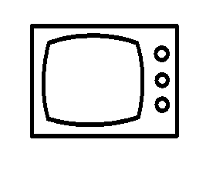

Watching TV

|  |
| --- |
| Things I like to watch |
| Things I never watch |

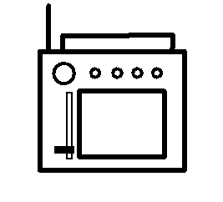

Listening to the radio

|  |
| --- |
| Things I like to listen to |
| Things I never listen to |

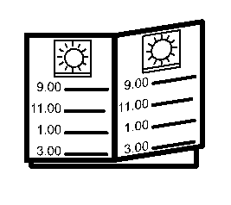

Special days I remember.

|  |  |  |
| --- | --- | --- |
| Birthdays | Details: | What I do to keep them special |
| Wedding anniversaries |  |  |
| Happy days |  |  |
| Deaths |  |  |
| Religious celebrations |  |  |
| **?**  Other |  |  |



Celebrating. . . .

|  |
| --- |
|  |

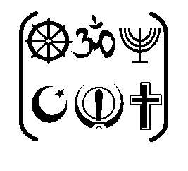

My faith or religion

|  |  |  |
| --- | --- | --- |
| What I eat | Details: | What I do to keep them special |
| What I wear |  |  |
| Rules I follow |  |  |
| My routines |  |  |
| Special days |  |  |
| Other |  |  |



Important things about my faith or religion

|  |
| --- |
|  |

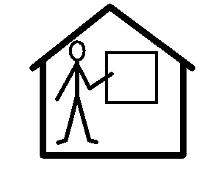

My education

|  |  |
| --- | --- |
| **?**  Where I went |  |
| What I liked |  |
| What I did not like |  |
| My friends |  |
| Other people |  |



My education

|  |
| --- |
|  |

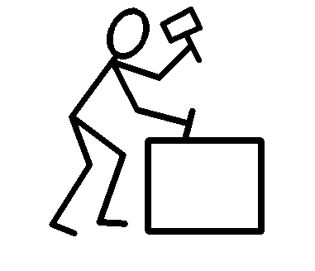

About my work

|  |  |  |  |
| --- | --- | --- | --- |
| ?  Where I worked | People at work | Things I liked | Things I didn’t like |
|  | | | |



My qualifications

|  |  |
| --- | --- |
| From school |  |
| From college |  |
| From work |  |
| From pastimes |  |



About my qualifications

|  |
| --- |
|  |

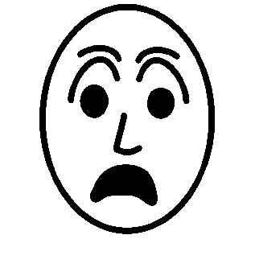

Things that frighten me

|  |  |
| --- | --- |
| Insects | Animals |
| People | **?**  Places |
| Travelling | Feelings |
| Crowds | Open spaces |
| Sounds | ?  Other |

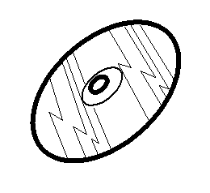 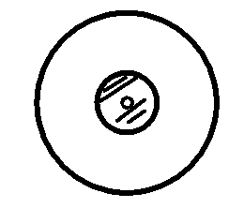

My favourite songs

|  |  |
| --- | --- |
|  | This song is called. . . .  This song is sung by. . . .  I like it because. . . .  I listen to it when. . . |
|  | This song is called. . . .  This song is sung by. . . .  I like it because. . . .  I listen to it when. . . |
|  | This song is called. . . .  This song is sung by. . . .  I like it because. . . .  I listen to it when. . . |
|  | This song is called. . . .  This song is sung by. . . .  I like it because. . . .  I listen to it when. . . |
|  | This song is called. . . .  This song is sung by. . . .  I like it because. . . .  I listen to it when. . . |
|  | This song is called. . . .  This song is sung by. . . .  I like it because. . . .  I listen to it when. . . |

How I like to look

|  |  |  |  |
| --- | --- | --- | --- |
|  | Likes | Dislikes | The help I need |
| Hair |  |  |  |
| Clothes |  |  |  |
| Keeping clean |  |  |  |
| Teeth |  |  |  |
| Nails |  |  |  |
| Feet |  |  |  |

How I like to look

|  |  |  |  |
| --- | --- | --- | --- |
|  | Likes | Dislikes | The help I need |
| Perfume |  |  |  |
| Aftershave |  |  |  |
| Shaving |  |  |  |
| Deodorant |  |  |  |
| Make-up |  |  |  |
| Other |  |  |  |

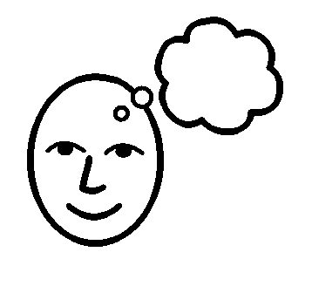

Special memories

|  |
| --- |
|  |

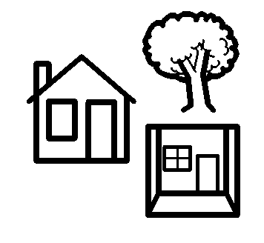

Special places

|  |
| --- |
|  |

My treatment and Care

Ideas and Advice

|  |  |
| --- | --- |
| Wishes for the future | |
| My choices: | What might happen |
| I choose | |

For further easy read/accessible documentation on End of Life Planning contact the Learning Disability team

|  |  |
| --- | --- |
| people | happy |
| sad | frightened |
| drinks | food |

|  |  |
| --- | --- |
| pets | special days |
| birthdays | Wedding anniversaries |
| Religious celebrations | Friends |