

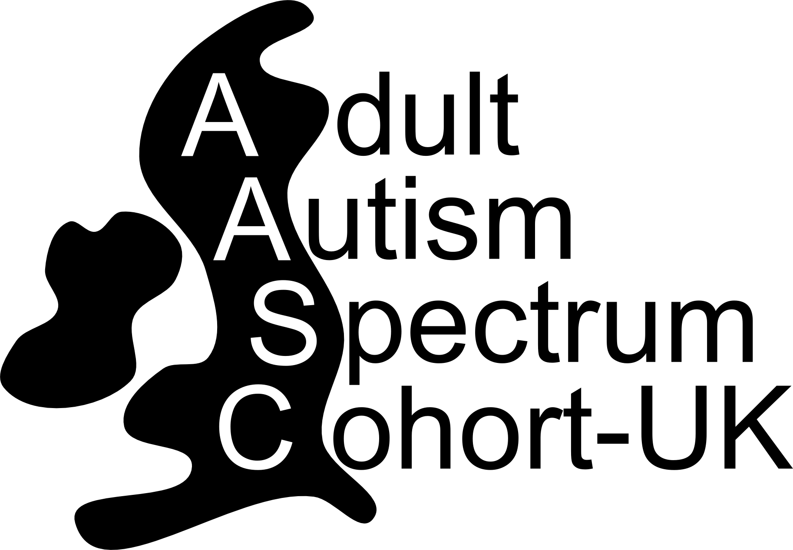

Contact booklet for adults on the autism spectrum

Learning about the lives of adults on
the autism spectrum

This booklet contains information about a research project
you may be interested in

Please read the information inside and then
complete either page 3 or page 4

Learning about the lives of adults on the autism spectrum

Background: Very little research has been undertaken into the life experiences of adults and older people on the autism spectrum

Aim of the study: To collect information from adults on the autism spectrum, and update the information from time to time, to see how people’s lives change.
What you would be asked to do in this study: If you are interested in participating in this study there are two ways you can join in. You can join up online at www.autismspectrum-uk.com Alternatively, you can fill out a contact form and we will contact you with paper forms about the project.
You will be asked to fill in a consent form and a questionnaire which will ask questions about your autism spectrum diagnosis and other information – like the types of support you receive, your employment opportunities, home, and information about aspects of your daily life. We will then contact you from time to time to ask you to give further information about your life. You will be kept informed about the study’s progress, and interesting findings, through newsletters and our website www.autismspectrum-uk.com
Potential benefits of the study: By taking part, you will help us with research that might lead to improvements in the services offered to people from the autism community. We will make sure our findings are shared with voluntary sector organisations, and government, to make sure we reach the people who can make these improvements.

Who is organising and funding this research study? This study is being run by the autism research team at Newcastle University, working with groups from across the UK. The team includes experienced autism researchers, researchers who are experts in adulthood and ageing, and adults on the autism spectrum and their relatives.
Will my information be kept safe? No personal information will ever be released to researchers or anyone else. Any information that is published will always be anonymised.

If you would like to take part, please fill in the form on the next page. If you don’t want to take part, please fill in the last page of this leaflet.

If you would like some more information please contact:
Adult Autism Spectrum Cohort - UK
Institute of Neuroscience
Henry Wellcome Building
Newcastle University
Framlington Place,
Newcastle upon Tyne
NE2 4HH
: adultautismspectrum@ncl.ac.uk Website: www.autismspectrum-uk.com
: 0191 2821380

For office use:
ID:
Contact Form for adults on the autism spectrum
To be contacted, please fill in this page of the form - leave the last page blank
Name

Gender | Male Female  I’d rather not say Other _____________________
Address (including postcode)
Date of birth | __ __/__ __/__ __ __ __ I’d rather not say
Autism Spectrum Diagnosis | - Autism  - Autism Spectrum Disorder(ASD)  - Autism Spectrum Condition(ASC)  - High Functioning Autism  - Asperger’s syndrome  - Pervasive Developmental Disorder (PDD) or PDD NOS  - Atypical Autism  - I have ASD but am unsure which category to select  - I think I have an autism spectrum diagnosis but have not had an assessment for a diagnosis  - I am awaiting an assessment  - I have another autism spectrum diagnosis (please specify)  ___________________________________________________________
GP or health team | Name:  Address:
Ethnicity | White Black/Black British I’d rather not say  Mixed Chinese/other group  Asian/Asian British Other ____________
Preferred contact method | Telephone Email Post
Telephone | Home number: Mobile number:
Preferred time to call | Anytime Morning Afternoon Evening
Leave voice message | Yes No
Email address
How did you hear about the study?  Voluntary  organisation | __________ _________________  Specify  Specify  Other  Local NHS organisation  Specify  __________________________________________
Would you like to receive our research newsletter? Yes No
If yes, what is your preferred method to receive the newsletter? Post Email
Signature/Mark |  | Today’s date:

Please return in the stamped addressed envelope to:
Adult Autism Spectrum Cohort - UK, Institute of Neuroscience, Henry Wellcome Building, Newcastle University, Framlington Place, Newcastle upon Tyne, NE2 4HH  0191 2821380
 adultautismspectrum@ncl.ac.uk website: www.autismspectrum-uk.com
If you DO NOT WANT to be contacted by us again, please fill in this page of the form and leave the other side blank
For people who do not want to take part, we have ethics committee and NHS permission to ask you for some information. We ask for this information so we can look at similarities and differences between the people who take part and those who don’t - for example, are the people who take part a similar age to those who don’t? This is important to us, so thank you for considering completing this section of the form - we won’t contact you again.
We ask for your postcode so we can check what type or area you live in. Once we have this information the last 3 digits will be deleted. We ask for the other information to help us understand something about adults on the autism spectrum who do not want to take part.
All information we ask for here is anonymous – no one will be able to identify you from your answers
I am happy for you to retain the following data | Yes No
Year of birth | __ __ __ __
Gender | - Male  - Female  - I’d rather not say  - Other (please describe)
Ethnicity | White Black/Black British  Mixed Chinese/other group  Asian/Asian British Other______________  I’d rather not say
Autism Spectrum Diagnosis | - Autism  - Autism Spectrum Disorder (ASD)  - Autism Spectrum Condition (ASC)  - High functioning autism (HFA)  - Asperger’s syndrome  - Pervasive Developmental Disorder or PDD NOS  - Atypical Autism  - I have ASD but am unsure which category to select  - I think I have an autism spectrum diagnosis but have not had an assessment for a diagnosis  - I am awaiting an assessment  - I have another autism spectrum diagnosis (please specify)
Postcode

Signature / mark

Please return in the stamped addressed envelope to:
Adult Autism Spectrum Cohort - UK, Institute of Neuroscience, Henry Wellcome Building, Newcastle University, Framlington Place, Newcastle upon Tyne, NE2 4HH  0191 2821380
 adultautismspectrum@ncl.ac.uk website: www.autismspectrum-uk.com

©Newcastle University 2014

