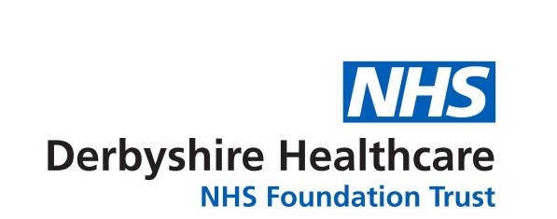

Entry Form – arts and crafts competition
‘Looking forwards’
Name of person submitting the entry:
Address (including postcode):

Telephone:
Email:

Age category: under 18 years 18 years and over (including adults)

Are you a: service user carer Trust member staff

governor volunteer other (please specify)

I understand that by entering this competition I give consent to Derbyshire Healthcare to use my name and/or entry in any publicity material and that it will be attributed to me unless I ask to remain anonymous. I understand that the copyright of the entry will remain with me.

Please tick this box if you do not want your name to be used and wish to remain anonymous.

By signing this form I am confirming that the entry is my original work, that I am the artist and that I am over 18 years of age.

Title of entry:
Signature:
Date:

The artist is under 18. I give my consent as parent/guardian:

(Name):
(Signature):
For guidance on how to enter, please see overleaf.
The closing date is midnight on 17 August 2022.

Arts and crafts competition guidance
‘Looking forwards’

- The competition is organised by Derbyshire Healthcare NHS Foundation Trust.
- Entry to this competition is open to Trust members, service users, carers, Trust staff, stakeholders, partner organisations and the voluntary sector.
- The Trust, along with the Council of Governors, is inviting people to share their hopes for the future now that many of the restrictions related to COVID-19 have been eased – and at the same time help raise awareness of our services and challenge health stigmas. The last year has been challenging for us all – we have been living with COVID-19 now for over two years and we want to share how you are looking forwards. We are keen to showcase your creativity and celebrate your achievements.
- Entry will be in two age categories – ages up to 18 years and 18 years and over.
- If you are interested in exploring your creative side and improving your wellbeing then email a clear image of your entry; it must be attached rather than embedded in the email. The competition aims to offer people the opportunity to express themselves and create meaningful artwork to share with others.
- You must complete the entry form and email it with your entry and a short paragraph (up to 200 words) explaining how art helps with your wellbeing. If you are shortlisted this will be included with your artwork.
- Your submission, along with the entry form, should be emailed to dhcft.membership@nhs.net. Due to the Trust’s infection prevention and control procedures, we are unable to accept entries by post.
- If you would like to find out more, please email dhcft.membership@nhs.net or telephone 01332 623723.
- After the closing date of 17 August 2022, a panel of judges will assess all the entries and establish a shortlist of finalists. The judges’ decision will be final. The shortlisted finalists will be invited to the Annual Members’ Meeting – see point 10 below.
- The winners will be announced at the Trust’s Annual Members’ Meeting (AMM) on Wednesday 21 September. The meeting will take place in the afternoon from 4pm. This meeting may be held face to face or virtually depending on the national guidance regarding COVID-19. We will contact the shortlisted artists in advance of the meeting and invite them to attend, and we will do our best to support the shortlisted artists to join the meeting. However, if the meeting is held virtually, we cannot unfortunately provide any IT equipment for this purpose. If we are able to hold the AMM face to face we will ask those shortlisted if we can display their work.
- Prizes (artist materials) will be presented at the AMM if face to face or posted after 21 September if it is a virtual meeting.
- The shortlisted entries will be featured on the Trust’s website; and in Trust publications; and in a booklet produced in-house.
- By entering the competition, you keep your copyright but you give permission to Derbyshire Healthcare NHS Foundation Trust to publish your entry and your name on the Trust’s internet and website (including social media); and to display your work on Trust premises.

About your personal information…
Any personal information you share will be used solely for processing your entry to the Trust’s writing competition. All applications will be held securely by Derbyshire Healthcare and we will never share or publish your information without your consent. We take your privacy seriously and promise never to sell your data.

