Supplementary toileting information for children who have a disability/additional needs.

Environment - It is important that your child feels comfortable – the bathroom should be clean, warm and inviting. Hang some familiar books and toys around to help your child to remain interested and occupied.

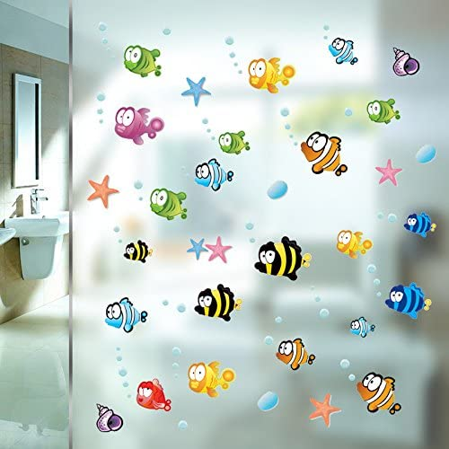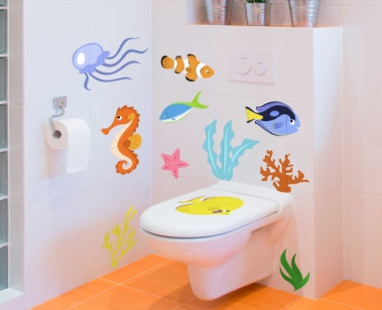

Sensory processing considerations - Many children experience sensory differences. This includes noise, smell, temperature, vision and proprioception. Therefore, it is important to consider sensory needs. Think about how you can adjust the environment to reduce their anxiety e.g. do they dislike the smell of the soap, when using the public toilets is the noise of the hand dryer going to raise their anxiety and frighten them; are the lights too bright. Some children are unable to tolerate the feel of toilet paper and you may need to use wipes instead.

Equipment - It is important that your child feels safe, secure and supported when toilet training.
This is particularly important when children have difficulties with proprioception (knowing where their body is in space). This is a common problem for children with disabilities. Having equipment that will support a good sitting position will help a child with proprioception problems feel grounded.

Potties - When choosing a potty for your child, consider looking for a chair type potty which will be more stable and supportive. (These can be purchased)

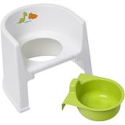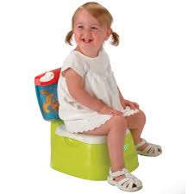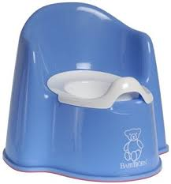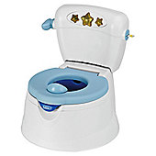

Toilets - If your child will be sitting on the toilet, he / she will need a child’s toilet insert and a step. This will enable him / her to feel stable and supported.

Toilet seat reducer - Usually padded and these are widely available. Some fit better than others; modern square toilets can be odd shapes! Some toilet seat ring reducers have handles which can be beneficial. Some secure under the main seat which can be better.

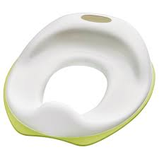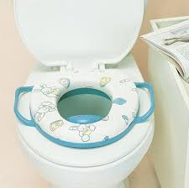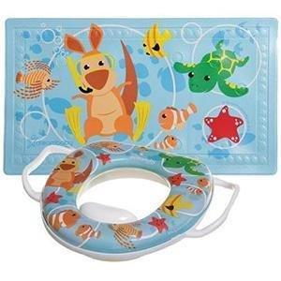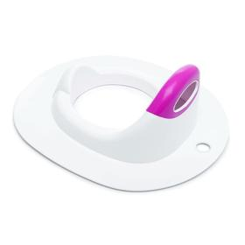
Steps - The step will maintain a stable sitting position and is not just an aid to climbing on to the toilet. Foot support gives stability and is available from many high street and on-line companies including Argos, Ikea and Amazon.
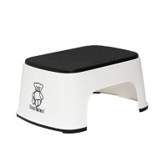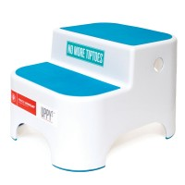
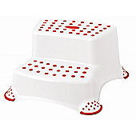
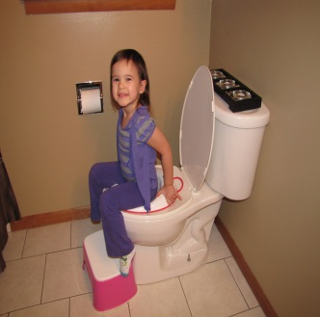
Combination seat and steps - These can be good but need to be sturdy and can work out more expensive.
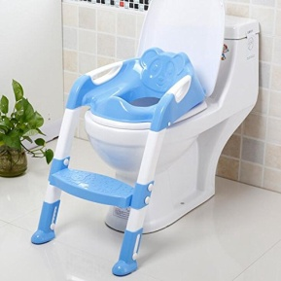

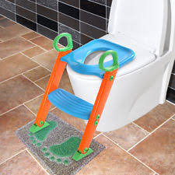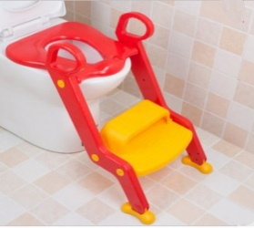
A non-slip mat under the step can be a good idea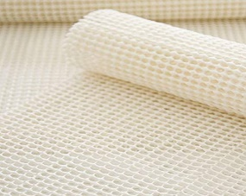.
Combination 3 in 1 or family toilet seats - These are useful and beneficial for other children in the house. It fits to the toilet as a regular toilet seat, has a lid, regular aperture seat and a smaller aperture seat. The child can lift/lower the seat ready to use. Also prevents movement which you can get with a ring reducer seat. This would need to be used with a step stool if feet don’t touch the ground.
Available from high street retailers - Homebase, B&Q, Dunelm and online retailers Amazon.

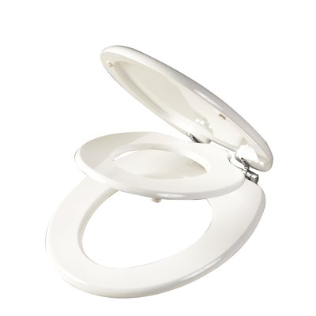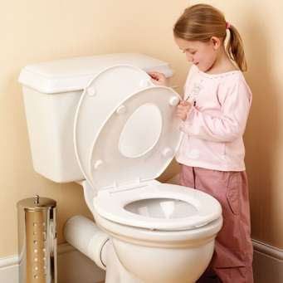

Grab Rails - A suckered wall grab rail can be beneficial if the toilet is close to the wall. Good for the bath too. NB Ensure it is firmly fixed each time before use. Useful for stability not pulling on!! Alternatively, permanent screw fixed grab rail can be obtained from Homebase, B&Q and other hardware stores and a handy man can fit. Sit the child on the toilet and see where their hand touches the wall. Fit the rail vertically or at a slight diagonal so as they grow the hand can reach move up the rail.
Available from High Street suppliers including: - Homebase, B&Q and on-line retailers. www.completecareshop.co.uk www.nrshealthcare.co.uk
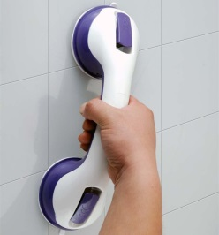
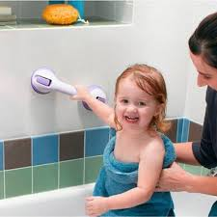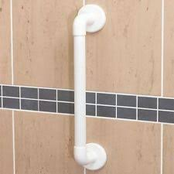
Specialist Equipment - If your child has difficulty in sitting / poor sitting balance, they may be unable to sit on the toilet or a potty. Discuss this with your Occupational Therapist / Senior Health Visitor Disability, as specialist equipment may be required.

Specialist Potty Chairs - These are expensive, and to order other alternatives must have been considered / tried to evidence why they are necessary. Occupational Therapists must submit as a special request. Examples of Smirthwaite Combi Children’s Toileting Chair.
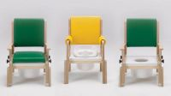
For additional information please see the following
Eric – www.eric.org.uk/
Toileting a guide for parents and carers - national autism society -autism.org.uk/toileting

