Name of Practice
Address
Address
Address
Address

Health Check Action Plan.

Dear (name of patient)

Following your annual health check, we have agreed the following actions to support you with your health.

 |  |  |  | By whom | By when
 |  | We recommend the following Treatment/tests/action. You need to make an appointment at your GP surgery for:
 | Blood Test
 | Urine test
 | Other test (details)
 | You should contact your surgery to discuss the results ………….. days after you have had the test

 |  | You need to make an appointment in ……… days/weeks with the practice nurse for:
 | Weight
 | Blood pressure
 | Ear syringe
 | Other procedure………….
 | We will refer you to the community learning disability team to see:
 | Community learning disability nurse
 | Speech & language therapist
 | Social worker
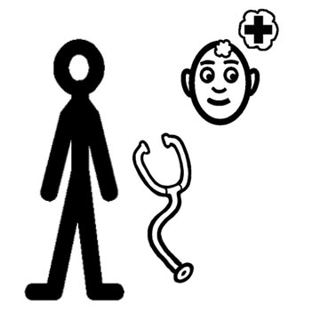 | Psychiatrist/psychologist
 | Other …….
 | We will refer you to your local health facilitator to support you with ……………………………
 | You need to make an appointment to see……..
 | Dentist
 | Optician
 | Podiatrist
 | Other local health professional
 | We will refer you to the hospital to see a specialist about your………………………………….
 | Additional actions

Thank you for attending today
Please keep this letter as it is part of your health action plan, and bring it to the surgery when you come.

Signed: ………………………………………….Doctor

Signed: …………………………………………..Nurse

